Electronic Passport Reader Device

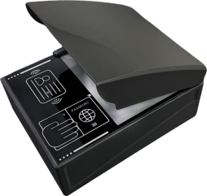

I. Product Overview 3
II. Core Functional Features 3
1. Covers global securities products with multilingual customization hassle-free 3
2. Full platform compatibility, with integration costs continuously decreasing 5
3. Powerful and efficient computing performance for an ultra-smooth recognition experience 5
4. Enhanced by smart software for a more intuitive user experience 5
5. Fully self-developed across the entire chain, integrating reading and authenticity verification 5
6. Full-scenario compatibility with optimal environmental adaptability 6
7. Multi-speed connectivity with unlimited networking deployment 7
8. Compact integration at the forefront, aligning with mainstream trends 7
III. Specifications and Parameters of ER Equipment 8
IV. Dimensions of ER Equipment 13
V. Display of interfaces and connections on the rear of the ER equipment 14
VI. Software Function Demonstration 15
VII. Application Scenarios 25
VIII. Successful Domestic Cases 27
IX. International Success Cases 32

I. Product Overview
The ER series passport readers represent a new generation of high-definition intelligent document information acquisition devices developed. Built on the Linux operating system, they integrate the company's proprietary TH-OCR technology, feature the RK3588 "Pentium Core" processor with integrated NPU computing power, and combine technologies from optics, mechanics, electronic circuits, artificial intelligence, and radio frequency identification (RFID). Guided by the core design philosophy of "pre-installed computing power, offline operation, and lightweight host systems," these devices enable rapid, accurate document recognition and secure verification.
Boasting advantages such as 13-megapixel high-definition imaging, 800 DPI resolution, 99.8% ultra-high recognition accuracy, millisecond-level response speed, military-grade durability, cross-platform compatibility, multi-scenario adaptability, comprehensive interface protocols, and robust hardware specifications, this product is widely applicable in various scenarios requiring document information registration and verification—including border checkpoints, airports, customs offices, hotels, tourist attractions, and immigration authorities—providing users with efficient, stable, and convenient document processing solutions.

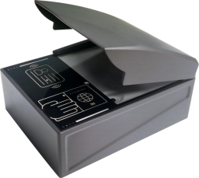
(Wear a sun visor)

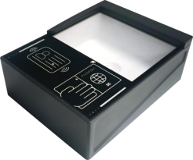
(No sunshade)

II. Core Functional Features

1. Covers global securities products with multilingual customization hassle-free
Fully compatible with the ICAO DOC 9303 international standard, supporting various travel documents including electronic passports, electronic travel permits for Hong Kong, Macau, and Taiwan, and travel permits for Hong Kong and Macau residents traveling to mainland China (including non-Chinese nationals); it also supports over 100 types of identification documents such as ID cards, foreign permanent residence certificates, residence permits for Hong Kong, Macau, and Taiwan residents, driver's licenses, vehicle registration certificates, military officer certificates, soldier certificates, and seafarer certificates—all requiring only a single device to meet diverse needs across multiple scenarios.
99.8% ultra-high accuracy rate: powered by the proprietary TH-OCR core technology, delivering industry-leading character recognition precision that effectively prevents misreading and missed readings while significantly reducing manual verification costs.
Barrier-free multilingual recognition: Supports English, Japanese, Chinese , Arabic, Thai, Korean, and more, seamlessly adapting to cross-border scenarios without additional language pack upgrades.

Agile custom development: Rapidly meets customized requirements for new document types, keeps pace with document updates and iterations, ensures long-term device compatibility, and maximizes user investment protection.

2. Full platform compatibility, with integration costs continuously decreasing
Lightweight host system design: requires only a 1MB development kit; SDK porting focuses solely on data transmission; theoretically supports cross-platform operation, significantly lowering integration barriers.
The system offers extensive compatibility: it supports mainstream operating systems including Windows, Linux, HarmonyOS NEXT, Android, iOS, and macOS, seamlessly integrates with domestic information technology innovation platforms such as Zhongbiao Kylin and UnionTech UOS, as well as domestic CPUs like Loongson and Zhaoxin, ensuring smooth integration for domestic application projects.

3. Powerful and efficient computing performance for an ultra-smooth recognition experience
NPU-powered computing capabilities: The RK3588 chip integrates an NPU, enabling independent execution of complex image analysis algorithms on the device side without relying on host computer performance and isolated from application systems for maximum stability.
Millisecond-level response speed: Electronic passport card reading in <3 seconds, second-generation ID card reading in <1 second, effortlessly handling high-concurrency scenarios.

4. Enhanced by smart software for a more intuitive user experience
Multi-mode reading options: 6 fixed modes plus 1 customizable mode, ranging from rapid 1-second MRZ recognition to full-light-source acquisition with integrated MRZ, VIZ, and RFID verification – switch seamlessly between modes for optimal efficiency and comprehensive coverage.
Powerful intelligent extraction capabilities: Supports precise extraction of portraits, approval seals, and text; extracts full-page content (including field coordinates) from unfamiliar documents; automatically identifies approval seal dates, port names, and entry/exit identifiers during border inspections, eliminating the need for manual extraction.
Highly customizable settings: Parameters such as resolution (400/800 DPI), image background removal, UV exposure intensity, brightness, and contrast can be adjusted to suit various document materials and lighting conditions for optimal recognition performance.
Enhanced with user-friendly features: includes a document authenticity verification pop-up (with customizable rules and duration), an automated restart function for the collection assistant "Watchdog," ensuring efficient performance in both testing and real-world use.
Intuitive Visualization: The EPR Demo features a clear interface layout with a progress bar displaying real-time processing status, 10 customizable buttons with free Chinese-English switching, and is easy for beginners to use.

5. Fully self-developed across the entire chain, integrating reading and authenticity verification
100% independently developed core technologies: From embedded software, electronic circuits, structural and optical path design to RFID card reading debugging, host computer application development, and image authentication algorithms—all processes are fully self-developed with no external technological reliance, ensuring complete mastery of core capabilities.
Dual-function identification and authentication: integrates rapid document recognition with advanced anti-counterfeiting capabilities, supporting UV anti-counterfeiting, infrared recognition, black-and-white copy verification, and BAC/PACE/PA/AA security certifications—with PA providing complete visualized authentication chain tracking—offering a one-stop solution for information collection and authenticity verification.

6. Full-scenario compatibility with optimal environmental adaptability
Unimpeded performance in bright outdoor conditions: The wide dynamic range camera features a mirrorless design that automatically adjusts exposure under direct sunlight, effectively eliminating reflection interference.
The external recognition accuracy remains unchanged.

Flexible multi-mode switching: choose between indoor/outdoor triggering modes or between always-on/triggered antenna settings, suitable for both fixed offices and mobile work environments with zero learning curve.
Advanced anti-interference design: Effectively resists both metal and signal interference, perfectly suited for complex installation scenarios such as access gates and self-service kiosks, ensuring stable performance regardless of environmental conditions.
Military-grade durability: Equipped with IP5 waterproof rating and 200,000-cycle wear-resistant high borosilicate glass (tested with a 650-gram weight), featuring detachable components for reduced maintenance costs; its snap-fit design offers excellent resistance to friction, corrosion, and static electricity, ensuring rock-solid performance even under prolonged high-frequency use.

7. Multi-speed connectivity with unlimited networking deployment
High-speed interface configuration: A dual-core combination of USB 3.1 (Type-C/Type-A) and Gigabit RJ45 interfaces delivers significantly higher data transfer speeds; expandable Wi-Fi/4G support eliminates cable constraints for wireless deployment, offering greater flexibility in mobile scenarios.
Full device compatibility: Supports both physical and virtual serial ports for seamless integration with traditional devices; mobile devices can connect via Wi-Fi (within the same LAN) or OTG USB for efficient work anytime, anywhere.
End-to-end security protection: 8–16-character password verifies network connections; access is denied without a password by default. Choose between LAN or direct connection mode for enhanced data transmission security against eavesdropping.

8. Compact integration at the forefront, aligning with mainstream trends
Highly integrated collaboration: The system achieves deep integration of "document recognition + QR code reading," featuring a unified design that combines OCR recognition, RFID card reading, and 1D/2D barcode identification. All modules work in synergy to ensure stable, high-speed continuous operation while significantly reducing integration costs.
Portable integration design: With compact dimensions of 185×143×66.7 mm and a lightweight weight of 0.98 kg, it can be easily integrated into portable devices for mobile business outreach and outdoor government service processing without complex setup. The miniaturized design significantly enhances desktop space utilization, making it aesthetically pleasing and practical for scenarios such as hotel front desks and telecom service centers. Aligned with the trend toward thinner self-service kiosks and access gates, its compact structure enables seamless integration into various terminals.

III. Specifications and Parameters of ER Equipment

order number | Parameter Name |  | Parameter Specifications
1 | hardware configuration | CPU | Four-core ARM Cortex-A76 + Four-core ARM Cortex-A55
2 | hardware configuration | NPU | NPU Computing Power: 6 TOPS
3 | hardware configuration | internal storage | 8GBLPDDR4x
4 | hardware configuration | memory | 32GBeMMC
5 | Sunshade |  | Removable with adjustable angle
6 | glass |  | Borosilicate float glass, Nu hardness 0.1/20 (ISO 9385):480; can be replaced from the top surface without disassembling equipment such as gate machines.
7 | image acquisition |  | Collection area: 126×91 mm, supports full passport size scanning  13 megapixels, maximum resolution 800 DPI  The images include: visible light, infrared light, and ultraviolet light images.
8 | communication mode |  | USB、 Ethernet
9 | USB Port |  | USB 3.1 Gen 1 Type-C: Used for connecting to a host computer
10 |  |  | USB3.1 Gen1 Type-A; Reader USB
11 |  |  | USB3.1 Gen1 Type-A; PC USB
12 | internet access |  | Gigabit RJ45 Interface
13 | HDMI Port |  | HDMI 2.1; supports display connection
14 | reset button |  | Long-press for 5 seconds to restore factory settings
15 | illuminant |  | Multi-band light source: includes visible light, infrared at 850 nm, and ultraviolet at 365 nm, with anti-glare functionality supported
16 | pilot lamp |  | Includes power indicator, ready indicator, error indicator, and reader indicator.
17 | Progress Indicator Light |  | Document reading progress indicator that allows users to customize the display mode
18 | buzzer |  | Built-in buzzer
19 | Image Rotation of Identity Documents |  | Supports automatic document rotation, allowing images from any orientation to be rotated after capture  All corrections display in the correct direction.
20 | Portrait Crop |  | The cropped image maintains intact facial and head regions.  The non-image area occupies a small portion of the image, and there are no light spots obstructing the photo.
21 | Reading machine-readable travel documents such as passports | MRZ | Capable of reading all machine-readable travel documents compliant with ICAO standards, as well as those issued by China that do not conform to ICAO standards.  Standard documents with MRZ (Machine-readable Code) information analyzed

22 |  | Read Card | Card reading rate: Up to 848 Kbps  Supports ICAO 9303 standard electronic passport card reading  Supports reading ISO 14443 Type A/B cards  Supports Basic Access Control (BAC, PACE) for electronic passports  Supports passive authentication (PA) for electronic passports to verify the authenticity of document information  Supports Active Authentication (AA) for electronic passports to verify the authenticity of the document chip
23 |  | VIZ Recognition | VIZ region recognition supports passports from multiple countries: United States, United Kingdom, Japan, Switzerland, Germany, Ukraine  Kran, New Zealand, Spain, Australia, Canada, China, Vietnam, Italy, Israel  Colombia, Brazil, Thailand, Belgium, Hungary, Somalia, Romania, Ghana, Turkey  Peru, Iraq, Portugal, Mexico, Maldives, Honduras, Singapore  Passports from nearly 200 countries or regions support VIZ recognition.
24 | Chinese mainland and Hong Kong, Macao, and Taiwan document recognition | OCR Recognition | Supports image capture and information recognition for various identification documents, including the second-generation ID card, Hong Kong/Macao Residents 'Permit for Traveling to and from Mainland China, Mainland Residents' Permit for Traveling to and from Hong Kong/Macao, Taiwan Residents 'Permit for Traveling to and from Mainland China, Mainland Residents' Permit for Traveling to and from Taiwan, Residence Permits for Hong Kong, Macao and Taiwan Residents, Golden Horse Permit, APEC Business Travel Card, Macao ID Card, Hong Kong ID Card, Border Resident Permit, Seafarer's Certificate, Driver's License, Vehicle Registration Certificate, Officer's Certificate, and Soldier's Certificate.  Image capture and information recognition for travel documents such as ICAO 9303-standard passports and visas
25 |  | Read Card | Second-generation ID cards, permanent residence ID cards for foreigners, residence permits for residents of Hong Kong, Macao and Taiwan, electronic travel permits for residents of Hong Kong and Macao to enter the mainland, electronic travel permits for residents of Taiwan to enter the mainland, and electronic travel permits for residents of Hong Kong and Macao to enter the mainland.  Mainland Travel Permit (for non-Chinese citizens): readable on both sides
26 | Reading Foreign Identity Documents |  | Supports ICAO 9303 standard passports, Malaysian ID cards, Singapore ID cards, and Philippine identity documents.  Document, Vietnamese ID card, South Korean ID card, Argentine ID card, Sri Lankan ID card, Chilean ID card  Feng Zheng ID card, Rwanda ID card, Peru ID card, Bolivia ID card, Egypt ID card, Qatar ID card  Saudi ID card, Italian ID card, Cambodian ID card, Thai ID card  Chinese driver's license, New Zealand driver's license, Malaysian driver's license, Japanese driver's license, Swedish driver's license, New Zealand driver's license  Driver's license; Thai driver's license; UAE driver's license; Indonesian driver's license; Mexican voter ID card.  More than 100 types of international documents, including the California driver's license in the United States
27 | Photosensitivity |  | Built-in light-sensitive response to prevent radio frequency interference  Prevent accidental NFC activation when scanning a mobile QR code
28 | operating system |  | Supports Windows, Linux, Kylin, UnionTech UOS, HarmonyOS NEXT, Android, and iOS.  Systems such as macOS
29 | Software Integration Method |  | (Windows, Linux, and domestic operating systems)  SDK (Windows, Linux, domestic operating systems)  HTTP, TCP, and serial communication protocols  Android SDK
30 | work environment | beam | Supports use in bright light environments such as direct sunlight, up to 50,000 Lux
31 | work environment | temperature | -10°C to 55°C
32 | work environment | humidity | 10%–90% RH, no condensation
33 | mains switch |  | Independent Power Switch
34 | source |  | Use an external standard power adapter with the following specifications:  Input: AC 100–240 V, 50–60 Hz, 0.8 A  output DC12V2A
35 | Anti-theft lock hole |  | Yes, 1

36 | pigment | dark grey
37 | Physical Specifications | Dimensions: 185 x 143 x 66.7 mm (length x width x height; excluding sunshade and mounting strip)  Net weight: 0.98 kg (excluding sunshade); Total package weight: 1.88 kg
38 | Service and Maintenance | Provide 24/7 phone, email, and online technical support  One-year hardware warranty with lifetime maintenance

IV. Dimensions of ER Equipment

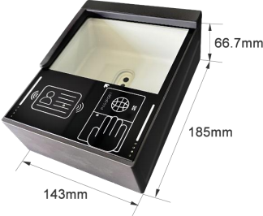

(ER device size without sunshade)
External dimensions: 185 × 143 × 66.7 mm (length × width × height)

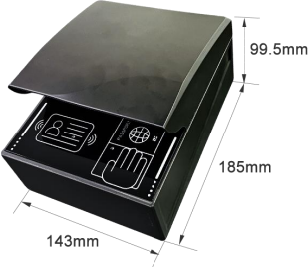

(ER device size with sunshade)
External dimensions: 185 × 143 × 99.5 mm (length × width × height)

V. Display of interfaces and connections on the rear of the ER equipment
1. Rear interface of ER equipment
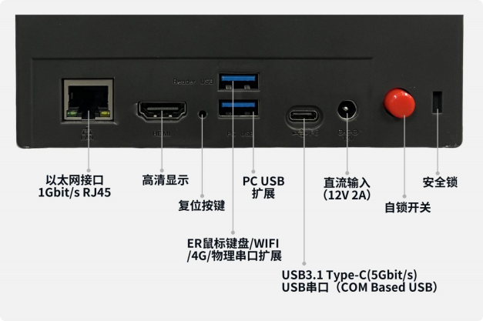

2. Demonstration of connecting
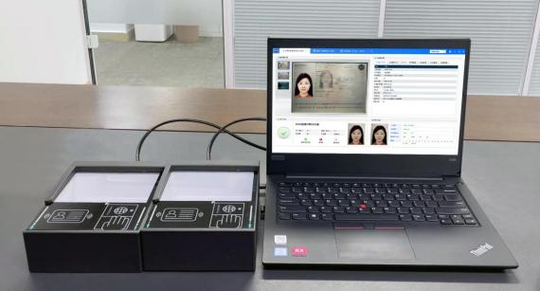
One computer or mobile device can connect to multiple ER passport readers simultaneously.

(2) Display of N Drag 1:
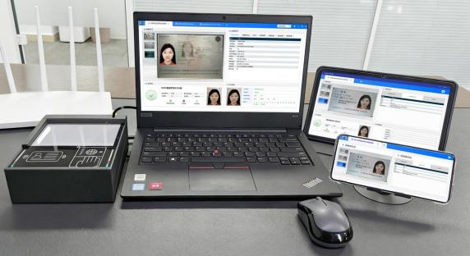
Multiple computers or mobile devices can be connected to a single ER passport reader simultaneously.

VI. Software Function Demonstration
(1) Display of document recognition types (partial display; supports over 100 document types)
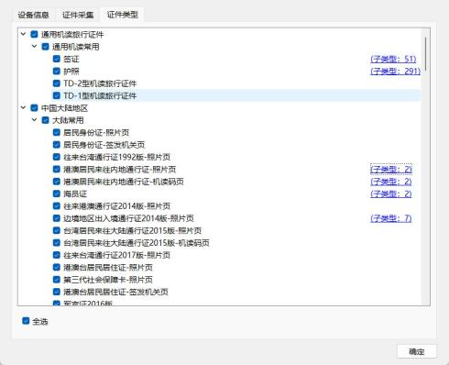
(Certificate types supported in the Chinese mainland region)

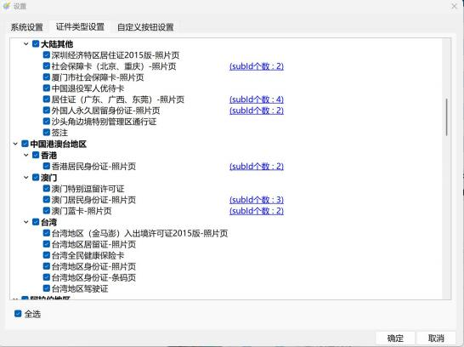
(Documents supported in Hong Kong, Macau, and Taiwan)
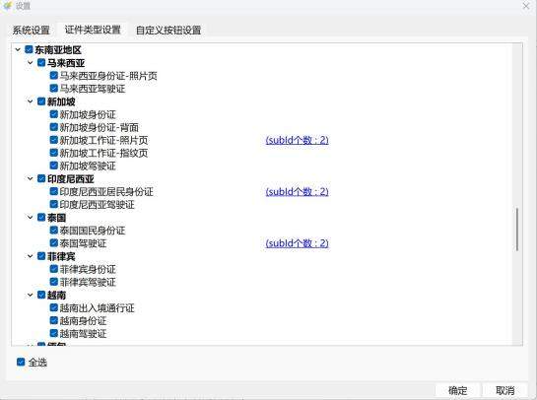
(Documents supported in Southeast Asia)

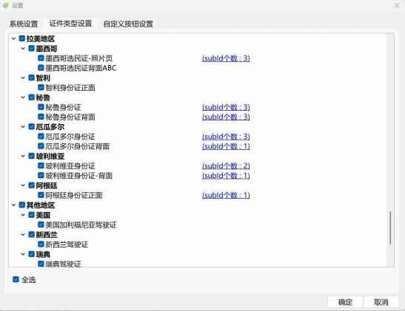
(Documents supported in Latin America)

(2) 6 fixed recognition modes + custom mode
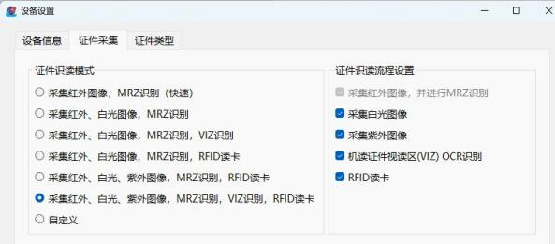

(3) Supports up to 800 DPI, with a default of 400 DPI:
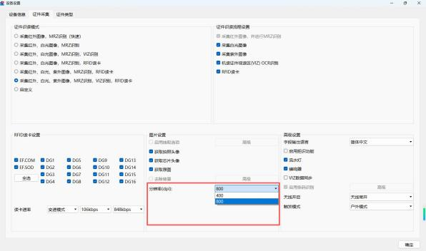

(4) Switch between indoor and outdoor modes freely
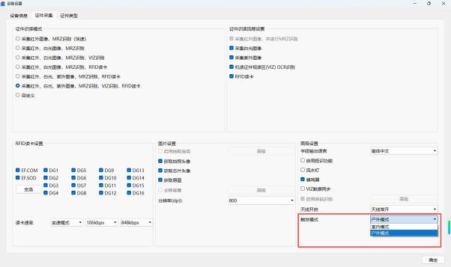

(5) Adjustable antenna activation status:
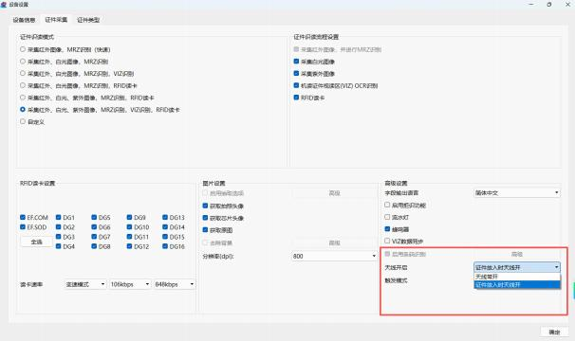

(6) Unrecognized document text extraction and recognition: When the text extraction and recognition feature is enabled, it can identify all layout information (including field contents and region coordinates) from unfamiliar documents (for which no corresponding template has been developed).
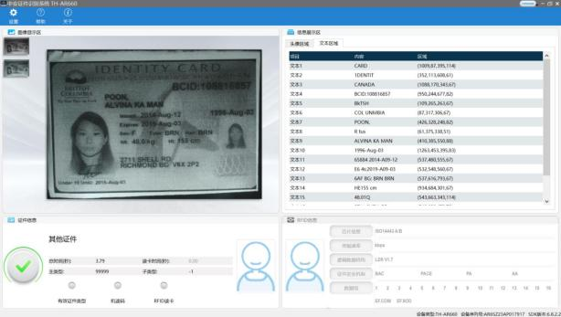

(7) Random avatar selection for unfamiliar documents: When the avatar selection feature is enabled, only document avatars can be selected for unfamiliar documents (for which no corresponding template exists). This feature is enabled by default.
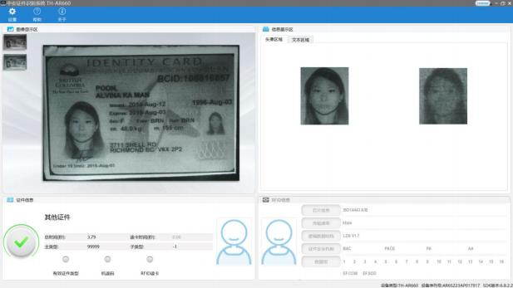

(8) Verification stamp extraction for identification: After enabling the verification stamp extraction function, you can identify the information on the verification stamp within documents, including (date, port name, entry/exit identifier).
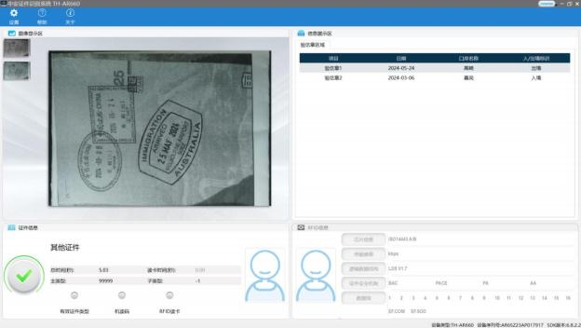

(9) ID card reading and recognition interface:
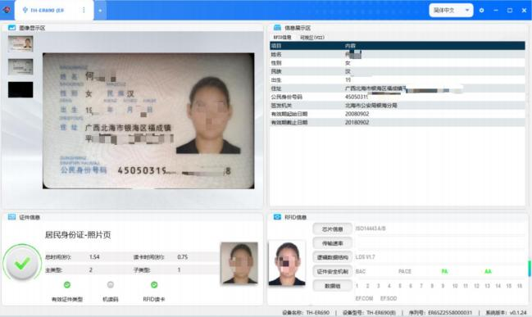

(10) Electronic passport RFID card reader interface:
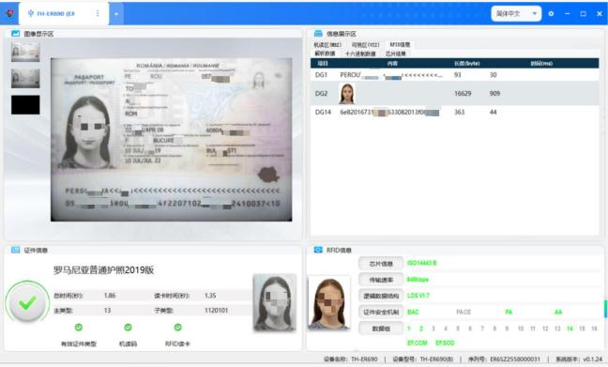

(11) Electronic passport MRZ machine-readable code recognition interface:
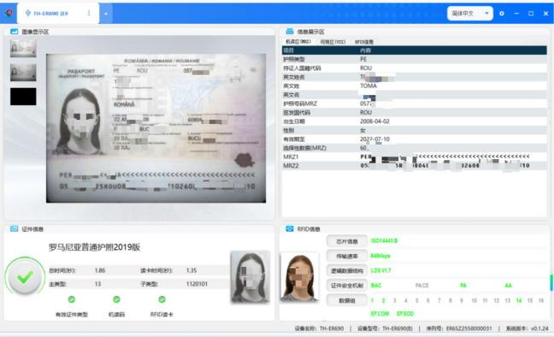

(12) Electronic Passport VIZ Reading Area Recognition Interface:
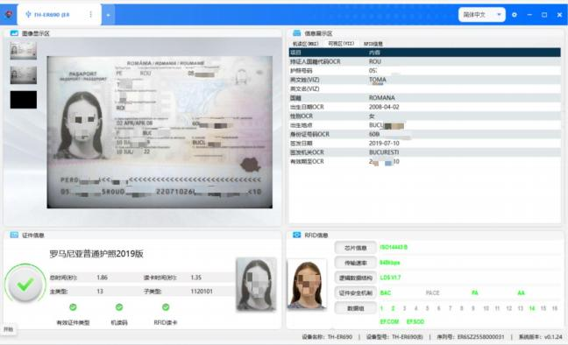

(13) Card reading interface for the Hong Kong/Macao Travel Permit:
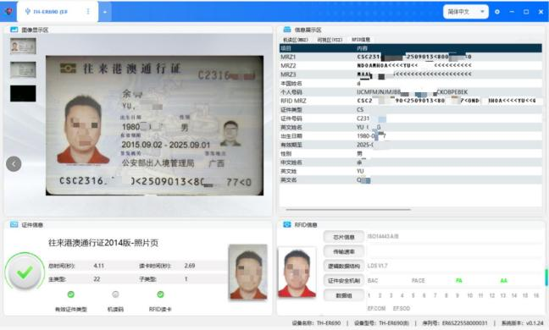

(14) Card reading interface for the Mainland Travel Permit for Hong Kong and Macao Residents:
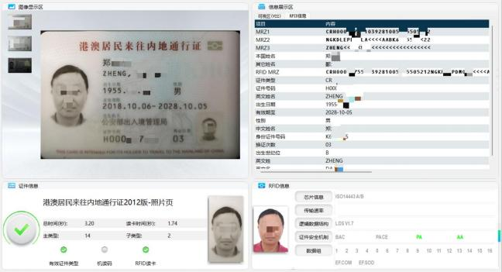

(15) Card reading interface for the Taiwan Travel Permit:
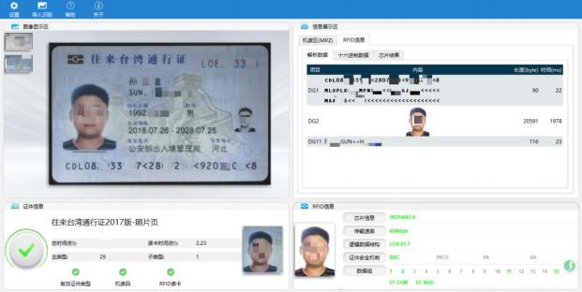

(16) Card reading interface for the Taiwan Resident Travel Permit to Mainland China:
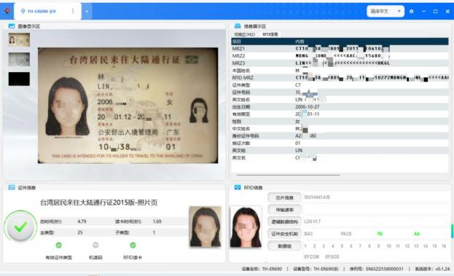

(17) QR Code Recognition Feature (Optional):
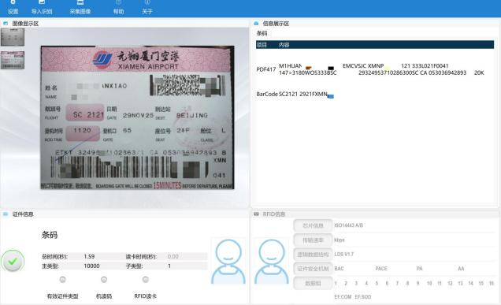

VII. Application Scenarios

Hotels: Management of guest information registration; Tourist Attractions: Integrated ticket vending/taking machines, ticket gates, and manual ticket windows.   Hotels: Management of guest information registration; Tourist Attractions: Integrated ticket vending/taking machines, ticket gates, and manual ticket windows.
Visitors: Registration and management of visitor information; Environmental protection: Real-name monitoring of vehicle exhaust emissions Visitors: Registration and management of visitor information; Environmental protection: Real-name monitoring of vehicle exhaust emissions
Airport: Automatic check-in, security screening and document inspection; Tax refund: Passport information registration for departure tax refund Airport: Automatic check-in, security screening and document inspection; Tax refund: Passport information registration for departure tax refund

Telecommunications: Real-name registration services available at service centers;   Travel Agencies:Passport registration for outbound travelers.  Telecommunications: Real-name registration services available at service centers;   Travel Agencies: Passport registration for outbound travelers.
Railway Station: Automatic ticketing and collection available for high-speed trains. Government authorities responsible: Entry-Exit Administration Bureau, Border Inspection Department, Inspection and Quarantine Bureau, Customs.Railway Station: Automatic ticketing and collection available for high-speed trains. Government authorities responsible: Entry-Exit Administration Bureau, Border Inspection Department, Inspection and Quarantine Bureau, Customs.
Venues: Concerts, sports events, sporting matches, and other performances. Tax exemption: Products purchased in duty-free shops under real-name registration are exempt from tax.

VIII. Successful Domestic Cases


Ministry of Foreign Affairs of the People's Republic of China

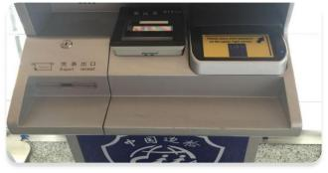
China Immigration Bureau Border Inspection System

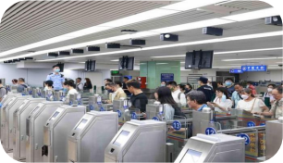
Shenzhen Luohu Port Border Inspection Station

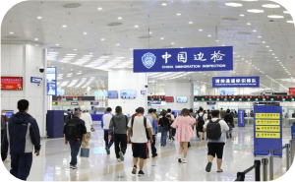
Zhuhai Hengqin Port Border Inspection Station


Customs Passenger Clearance System for Passengers at All Levels of National Border Control

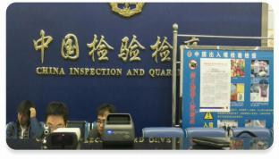
Customs and Quarantine Systems throughout the Country

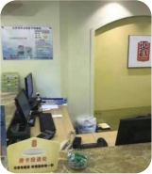
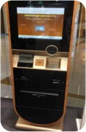

Visitor Management System; Public Security Hotel Industry Security Management System Visitor Management System; Public Security Hotel Industry Security Management System


China Merchants Bank Desktop Version

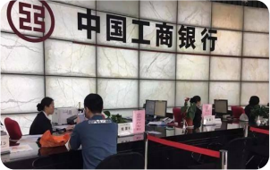
Industrial and Commercial Bank of China Desktop Version

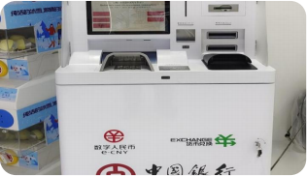
Bank of China Foreign Currency Exchange Machine

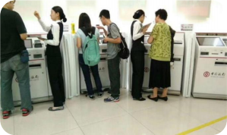
Bank of China VTM Machine

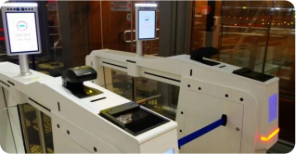
Beijing Daxing Airport

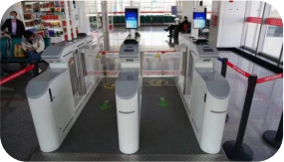
Gansu Lanzhou Airport

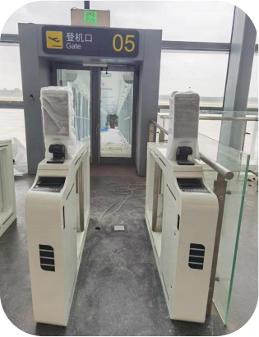
Jining Airport

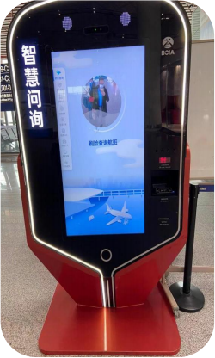
capital airport

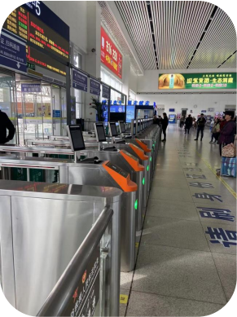
Changzhou North High-Speed Railway Station

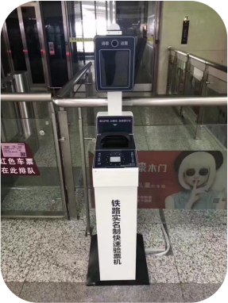
Suzhou North High-Speed Railway Station

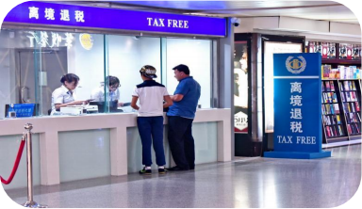
Tax Refund Store for Departing Citizens

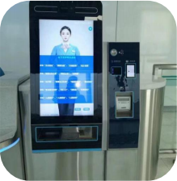
Shenzhen Metro Line 6 Extension

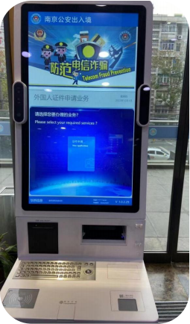
Nanjing Public Security Bureau's Entry-Exit Administration Department

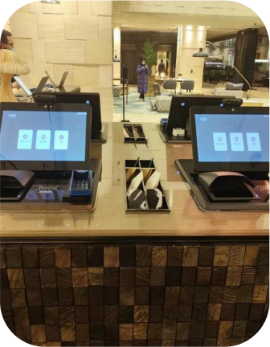
Hotel Smart Counter

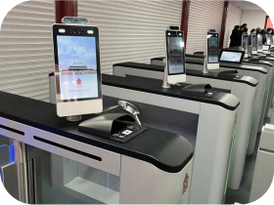
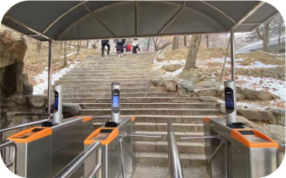

Beijing Palace Museum
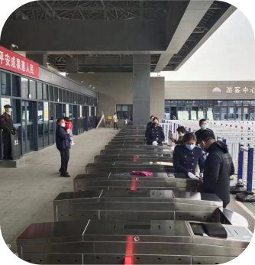
Xi'an Qin Shi Huang Mausoleum Museum

Beijing Mutianyu Great Wall
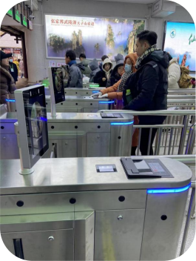
Wulingyuan Scenic Area, Zhangjiajie, Hunan Province

IX. International Success Cases









Digicel om uFC



















